**Ideation Phase**

**Define the Problem Statements**

|  |  |
| --- | --- |
| Date | 30-06-2025 |
| Team ID | LTVIP2025TMID43096 |
| Project Name | Flight Finder: Navigating Your Air Travel Options |
| Maximum Marks | 2 Marks |

**Customer Problem Statement Template:**Create a problem statement to understand your customer's point of view. The Customer Problem Statement template helps you focus on what matters to create experiences people will love.  
  
A well-articulated customer problem statement allows you and your team to find the ideal solution for the challenges your customers face. Throughout the process, you’ll also be able to empathize with your customers, which helps you better understand how they perceive your product or service.

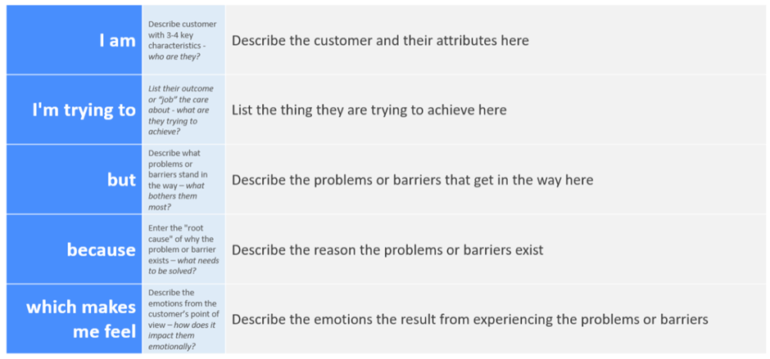  
  
**Reference:** https://miro.com/templates/customer-problem-statement/

**Example:**

|  |  |  |  |  |  |
| --- | --- | --- | --- | --- | --- |
| **Problem Statement (PS)** | **I am (Customer)** | **I’m trying to** | **But** | **Because** | **Which makes me feel** |
| PS-1 | I am a frequent traveler who often books flights online. | I’m trying to find and book the best available flights quickly and efficiently. | But the existing platforms are either cluttered, slow, or lack real-time availability. | Because they don't integrate operator-side updates or simplify customer experience. | Which makes me feel frustrated and uncertain about my travel plans. |
| PS-2 | I am a flight operator responsible for keeping flight data updated. | I’m trying to manage schedules, seat inventory, and communicate changes in real-time. | But I don't have access to a centralized, easy-to-use system for doing so. | Because existing tools are either too complex or not built for airline operations. | Which makes me feel overwhelmed and prone to errors. |

